Step 1: Confirm Java version 1.7 and above is installed

Step 2: Confirm Eclipse version 4.x and above is installed

Step 3: Download Selenium Java client drive

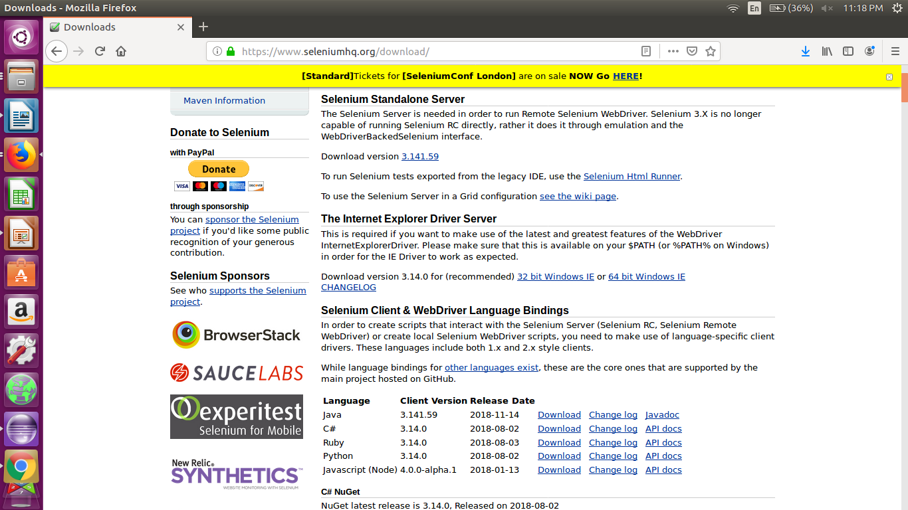

Step 4: Unzip the downloaded driver into a directory of your choice (preferably non C drive on windows)

Step 5: Start eclipse

Step 6: Create a new Java Project.

Step 7: Add all the Jar files from the unzipped selenium client folder

from ‘libs’ folder as well as from the selenium client root

Step 8: Download a helper executable for specific browser

Step 9a: For Chrome download ChromeDriver

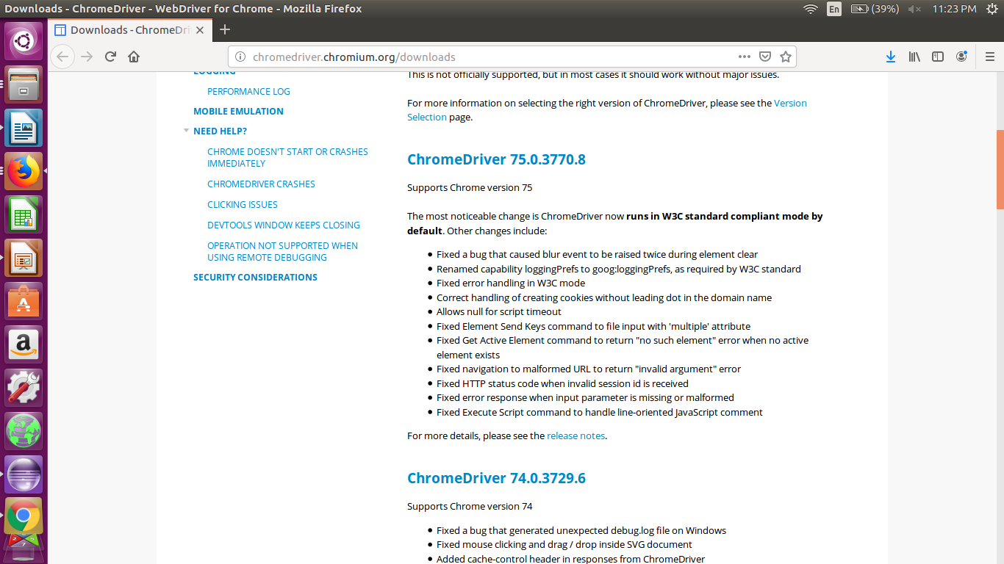

It is recommended to download the current stable version (74.x) rather than beta (75.x) as the beta supports only Chrome v75, which may not yet be available easily.

Step 10 a: After clicking on relevant version number, choose the archive corresponding to your OS and unzip the executable in a folder

Step 9b: For firefox downlonad geckodriver

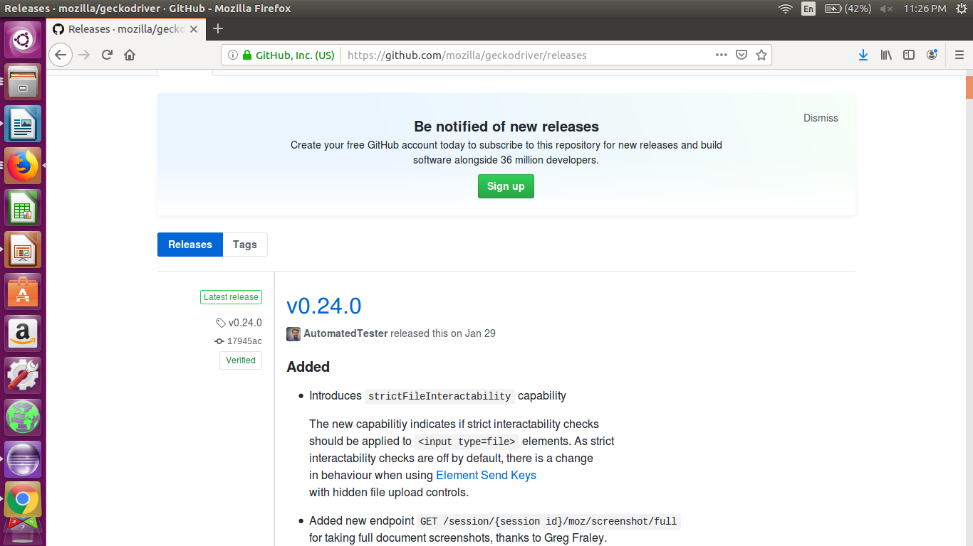

Step 10b. Download v0.24.0 and unzip the executable in a folder.

Step 11: Create a Java Class

Step 12: Add the following code into the main() function

System.setProperty("webdriver.chrome.driver","/home/abc/Software-installers/SeleniumClient/chromedriver");

WebDriver driver=new ChromeDriver();

driver.get("http://fispl.co.in");

// driver.manage().timeouts().implicitlyWait(3, TimeUnit.SECONDS);

String title=driver.getTitle();

System.out.println(title);

Step 13: Execute the code, it may show a screen as follows:

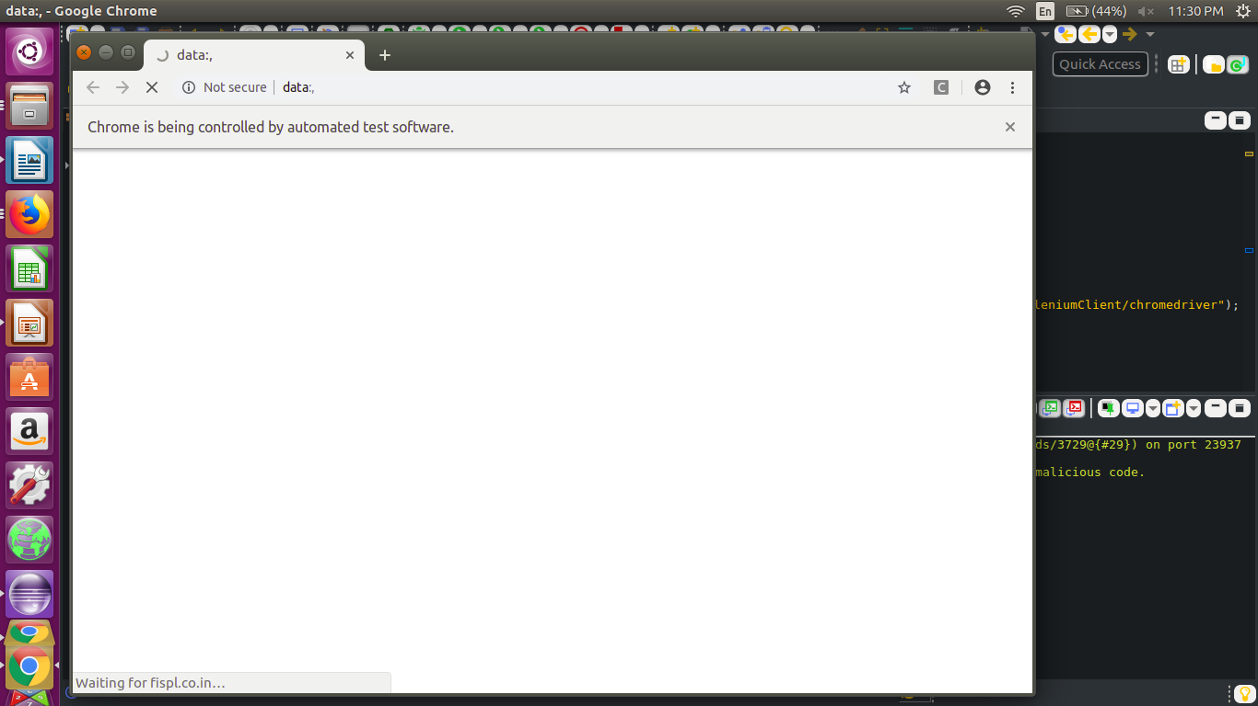

Step 14: Confirm the printed value on Eclipse console, it should have printed the following messages (or similar)

Starting ChromeDriver 74.0.3729.6 (255758eccf3d244491b8a1317aa76e1ce10d57e9-refs/branch-heads/3729@{#29}) on port 23937

Only local connections are allowed.

Please protect ports used by ChromeDriver and related test frameworks to prevent access by malicious code.

Jun 03, 2019 11:30:35 PM org.openqa.selenium.remote.ProtocolHandshake createSession

INFO: Detected dialect: OSS

Finitely Infinite Systems Private Limited

If you are getting message as shown above, the Selenium Web driver is installed and ready to use.